**IBM - Naan Mudhalvan-Data Analytics with congnos**

**Phase 3**

**Development Part 1**

**Student Name : AHMAD**

**Register Number : 620821104005**

**Branch : B.E CSE**

**Year : 3rd Year**

**Topic : Data Analytics with Cognos**

**Title : COVID- Vaccines Analysis**

**College : Gnanamani College of Technology**

**Introduction**

**The COVID-19 pandemic has spurred unprecedented efforts in vaccine development and distribution. As vaccines are administered to millions of people worldwide, it is crucial to monitor and optimize the distribution process while closely monitoring adverse effects. Advanced machine learning techniques can play a pivotal role in achieving these goals.**

**Objectives**

In this phase defines start to building the Project by loading and preprocessing the dataset and perform different analysis and visualization using IBM Cognos.

**Data source**

Dataset is collected from the kaggle.com named “daily-website-visitors.csv” which has a data about the Days, Day of week, Date, page Loads, Unique visits, First-time visits, Returning Visits.

Dataset link:

<https://www.kaggle.com/datasets/gpreda/covid-world-vaccination-progress>

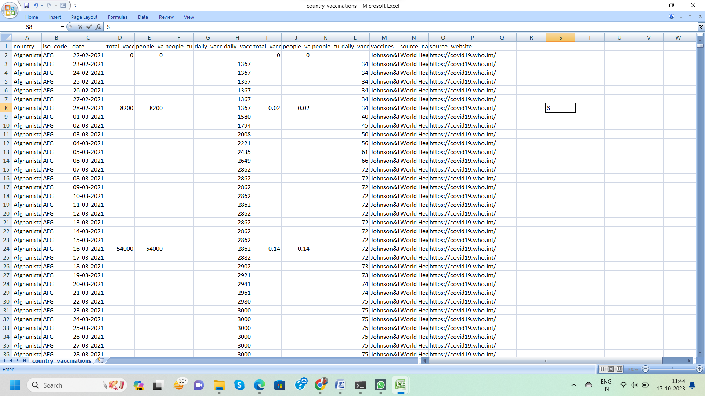

**Data Loading**

Steps Involved in data loading on IBM cognos.

1. **Login to your IBM cognos**
2. **Click more menu from the left side**
3. **Select new tab**

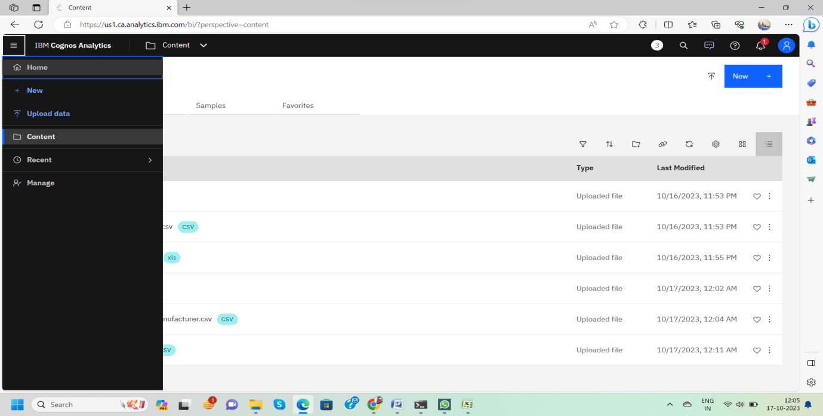**4. Click Data module tab**

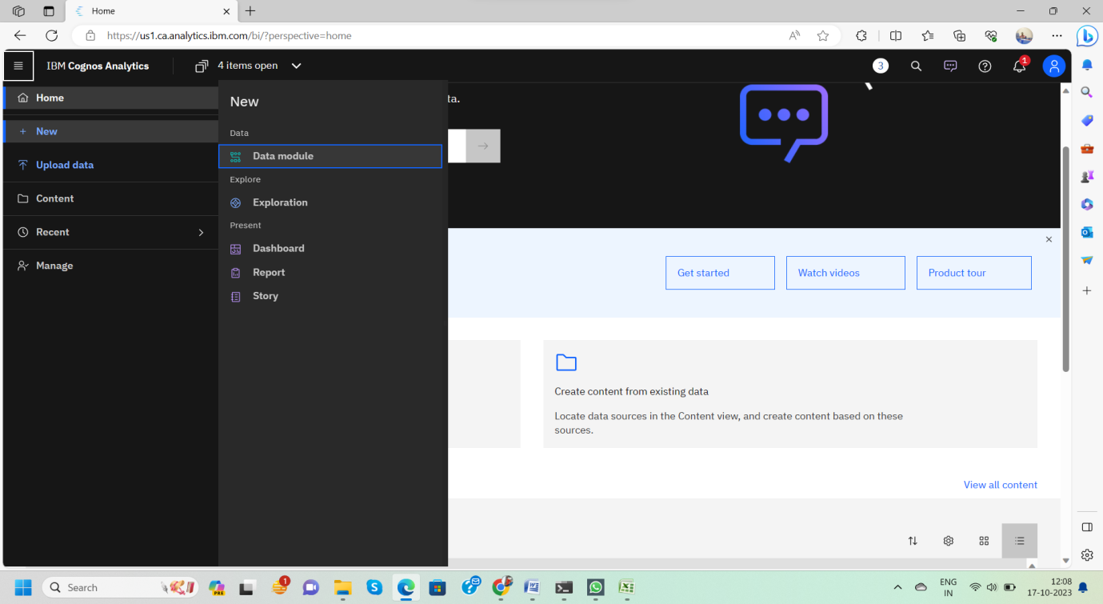

**5.Upload the dataset for your project and select the Corresponding file**

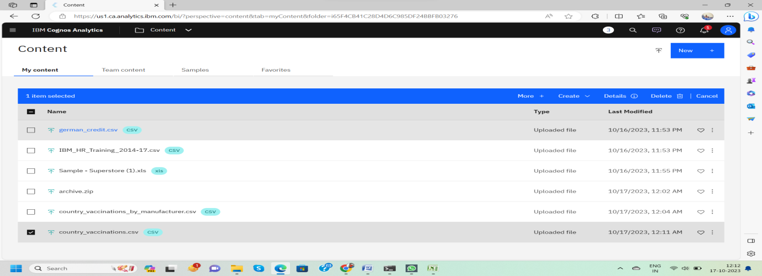**6. preview the data**

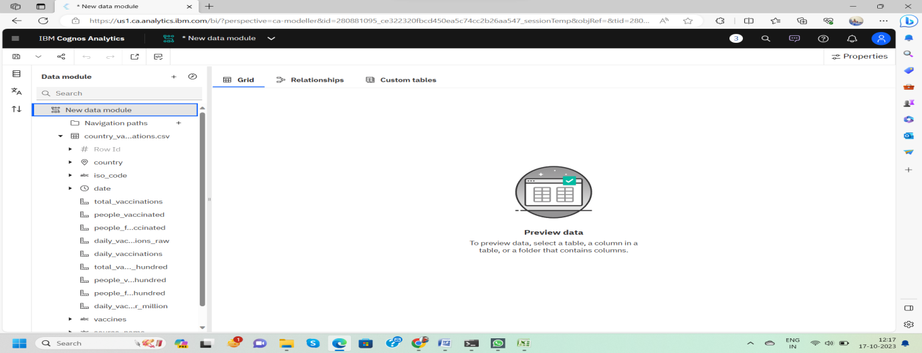**7.Explore the data**

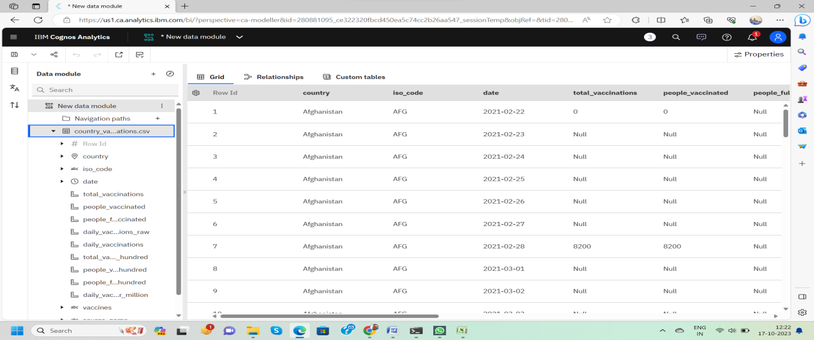

**8. save the data module**

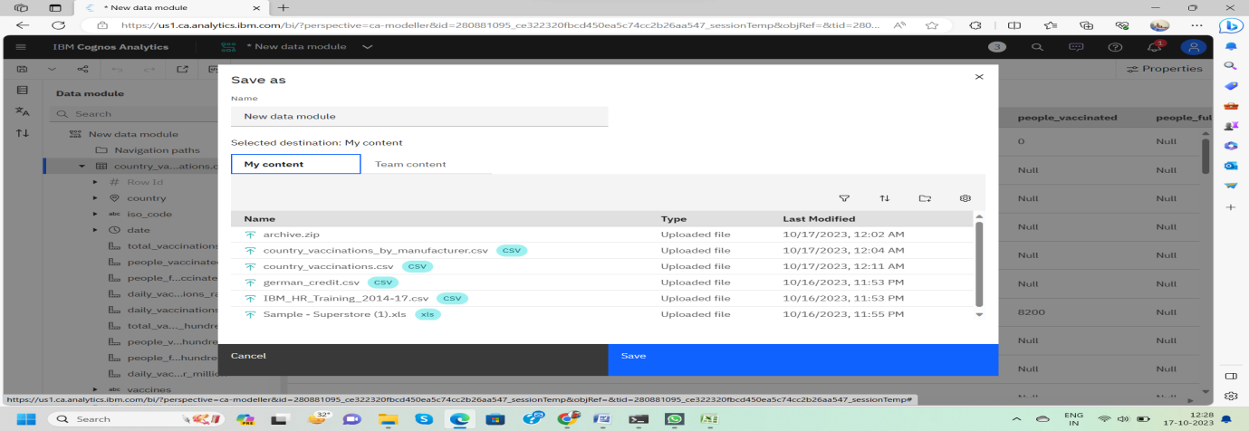

**Data Preprocessing and Cleaning**

In this phase the following steps will taken

* Handling missing data
* Data Transformation
* Data Type Conversion
* Removing Duplicates
* Dealing OutliersOnce you saved the data module.
* Click the corresponding dataset on IBMcognos and Preview the mosuleRight
* Click the row where you want to clean the data It provides the UI to Clean the data and makes the task easy one, Now Updating and Replacing the Null values are simple

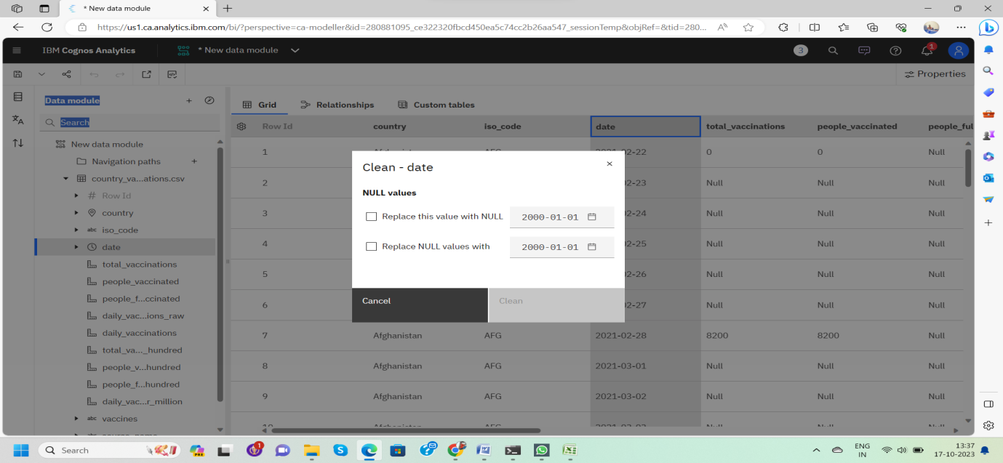data module will be updated by doing the above process

after the completion of process start creating the dashboard for Visualization

**Dashboard Creation**

**Dashboard creation are helpful to visualizing the data**

1. **Goto Home menu**
2. **Select the new tab**
3. **Click dashboard**

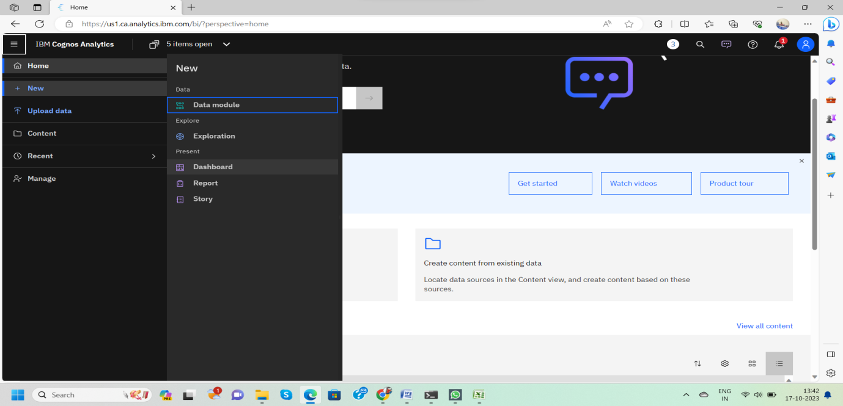

**4. Choose the template for your project and click**

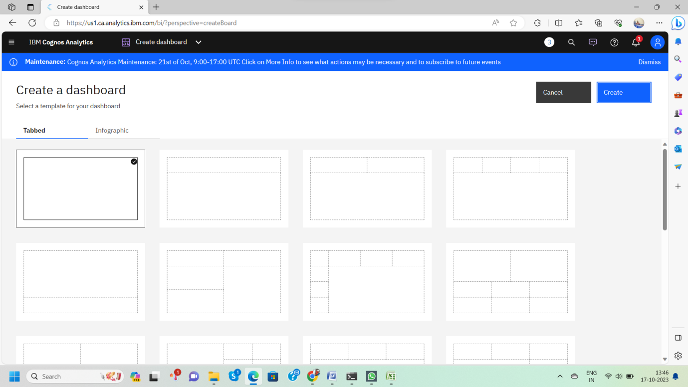

**5.Now Dashboard is created**

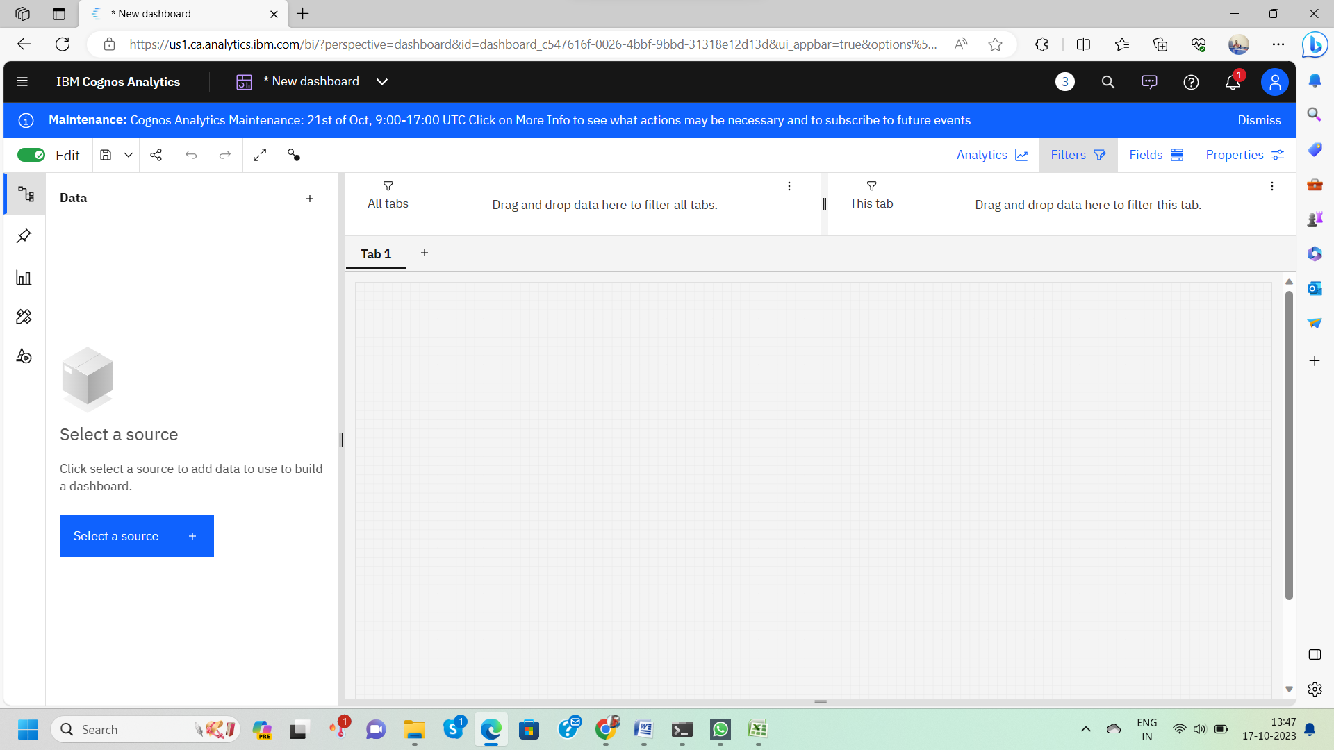

**6. Select the data source**

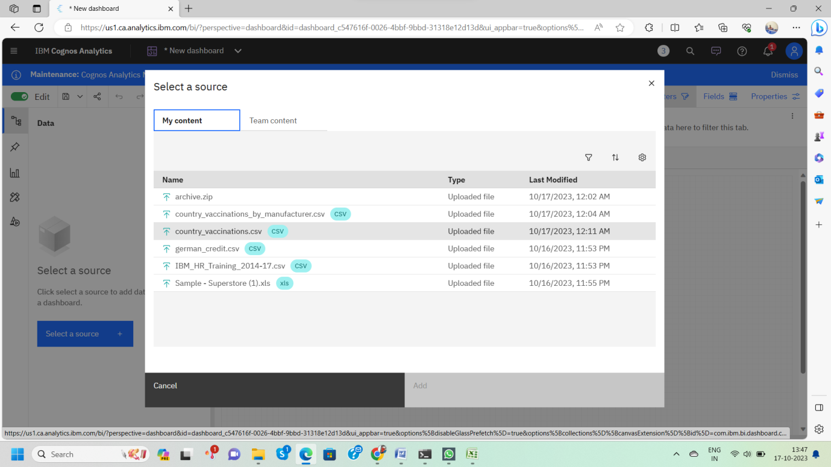**Visualization**

**After creating the dashboard, the next step is to visualize the data**

**In IBM Cognos**

**1. Goes to the Corresponding Dashboard**

**2. select the visualizations tab in the left side of title bar**

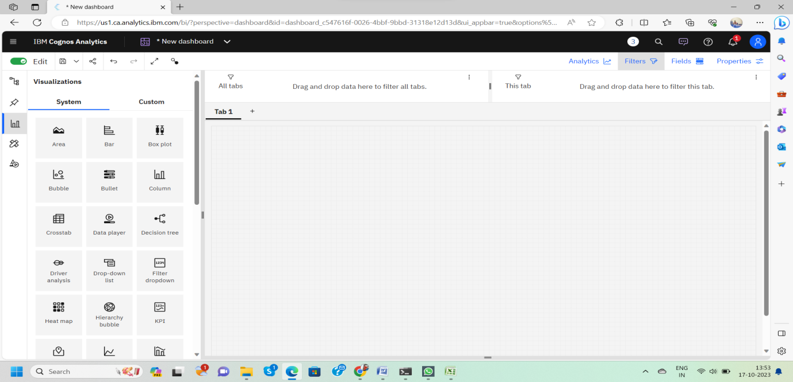

**3.Choose the system as you want and put the data source for the required columns**

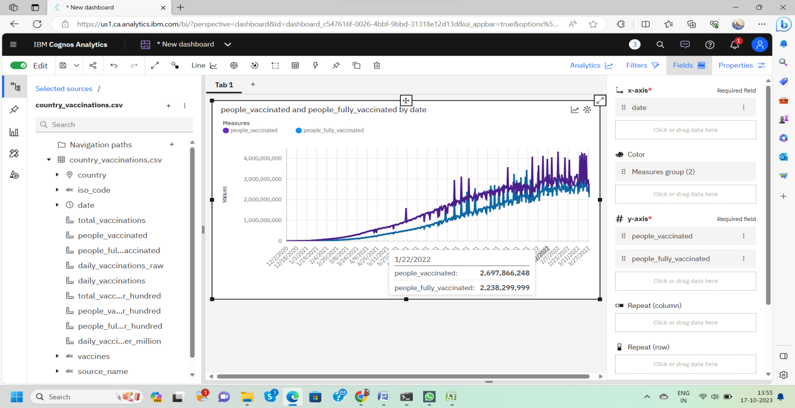In the above screen shot displays the Line graph and model compares the “**people _vaccinated**” and “**people _fully _vaccinated**” from the time period of 2020 to 2022

X-axis =**Dates**

Y-axis = **people _vaccinated, people _fully _vaccinated**

After performing these activities a comprehensive document will be created to demonstrate the ability to Communicate and share finding.

**Conclusion**

In this initial phase of our COVID-19 vaccine analysis project, we successfully collected and preprocessed the vaccine data. This crucial step lays the foundation for our in-depth analysis, allowing us to work with clean, structured data. With this data in hand, we're well-positioned to move forward with our investigation, gaining valuable insights into the efficacy, distribution, and impact of COVID-19 vaccines. Our commitment to data quality and integrity ensures the reliability of our findings as we contribute to the ongoing fight against the pandemic.